

|  |  |
| --- | --- |
| **TEAM NAME** | **def_SAM (TEAM 2)** |
| **PROJECT NAME** | **SAM 2017** |
| **DATE OF SUBMISSION** | **12/06/16** |

**TABLE OF CONTENT**

|  |
| --- |
| 1. ***Domain Model***   *1.1 Composite Domain Model …………………………………………..4*  *1.2 Domain Model for Paper Submission………………………………5*  *1.3 Domain Model for Paper Assign, Review and Rate……………..6*  ***2****.* ***Use case Diagram ……………………………………………….****7*  *2.1 Use case specification…………………………………………….8*  *2.1.1 Use case specification for Submit Paper………………………..9*  *2.1.2 Use case specification for Assign Paper………………………..10*  *2.1.3 Use case specification for Choose Paper………………………11*  *2.1.4 Use case specification for Review Paper………………………12*  *2.1.5 Use case specification for Rate Paper…………………………13*  *2.1.6 Use case specification for Manage Conflicts …………………14*  *2.1.7 Use case specification for Final Rate.………………………….15*  *2.1.8 Use case specification for Send Notifications…………………16*  *2.1.9 Use case specification for Set Deadlines……………………...17*  *2.1.10 Use case specification for Send Daily Reminders…………..18*  *2.1.11 Use case specification for Define Template………………….19*  *3.* ***System Sequence Diagram****……………………………………….20*  *3.1 System Sequence Diagram for Paper Submission……………..21*  *3.2 System Sequence Diagram for Paper Assignment…………….22*  *3.3 System Sequence Diagram for Paper Review and Rate……...23*  *4.* ***Architectural Model ………………………………………………****24*  *5.* ***Detailed Design Model……………………………………….…..****25*  *5.1 Class Diagram……………………………………………….……26*  *5.2 State Diagram………………………………………………….....27*  *5.3 Activity Diagram…………………………………………………..28*  *5.3.1 Activity Diagram with Admin…………………………………..29*  *5.3.2 Activity Diagram with System……………………………….30*  *5.4 Design Level Sequence Diagram…………………………….31* |

***1.Domain Model***

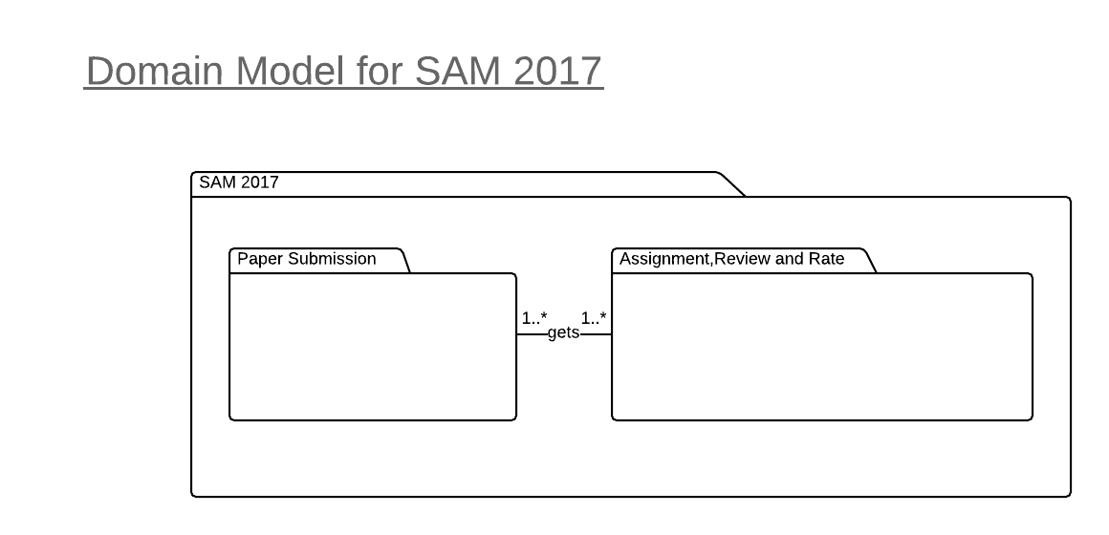

1.1 Composite Domain Model

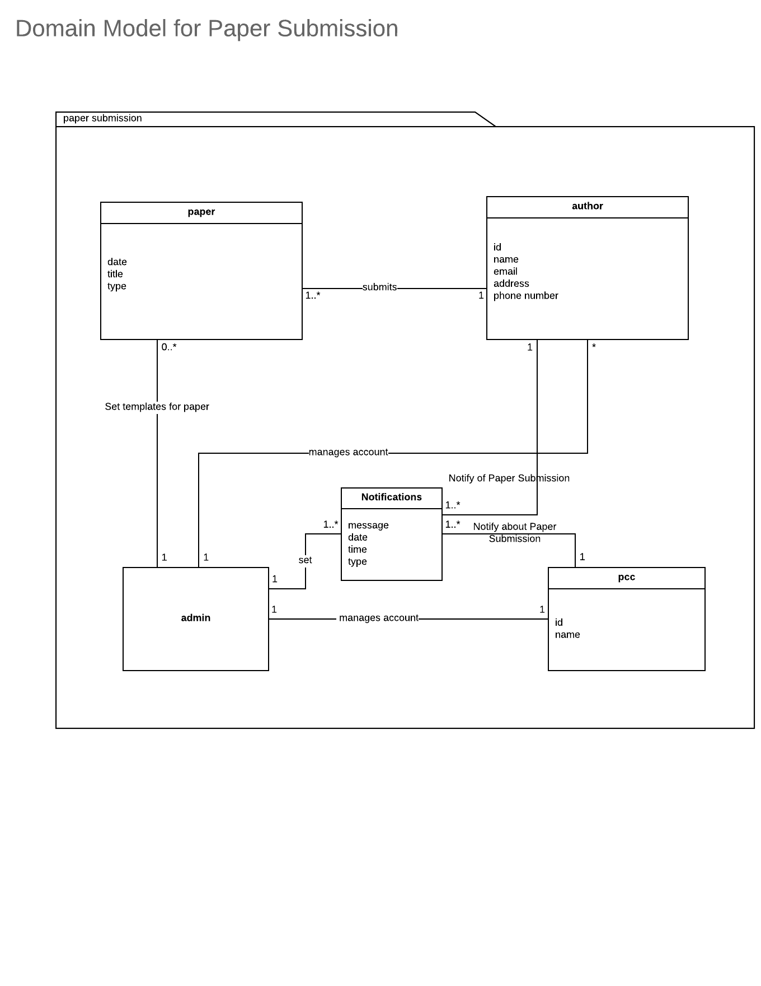

1.2 Domain Model for Paper Submission

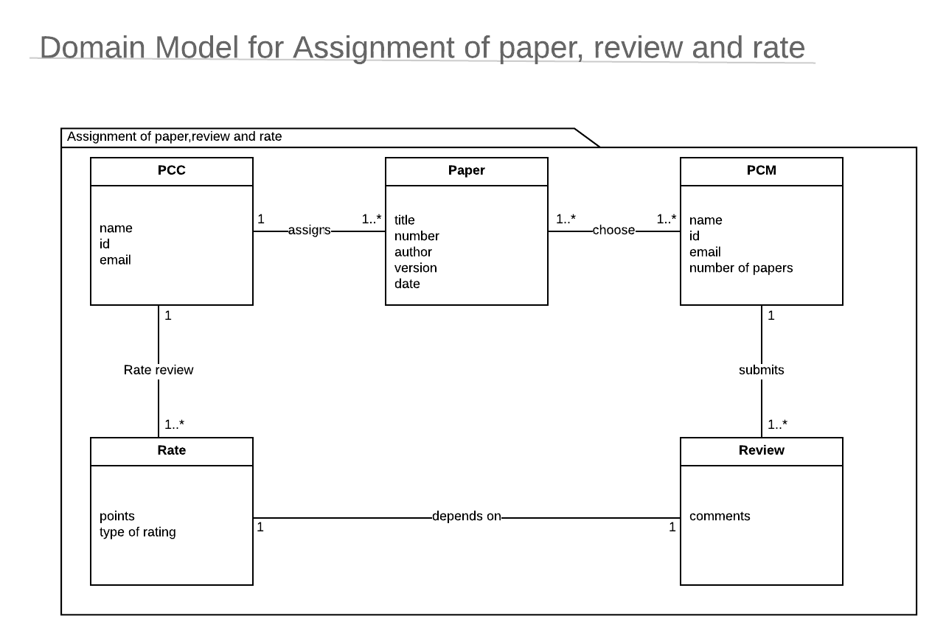

* 1. Domain Model for Paper Assign, Review and Rate

**2.Use Case Diagram**

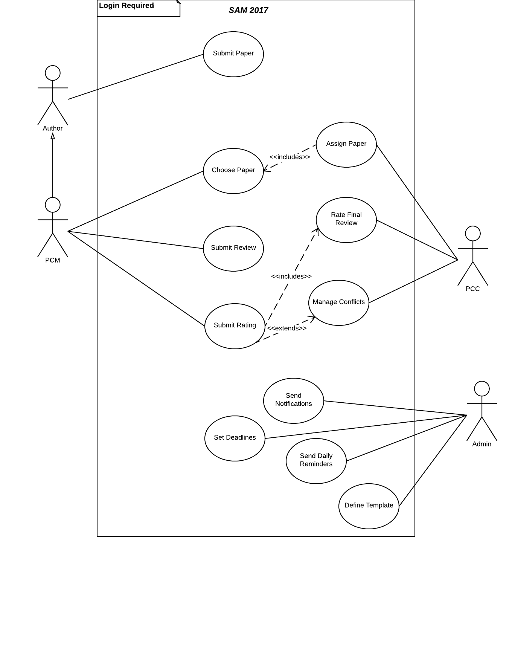

**2.1 Use Case Descriptions**

**Revision History**

|  |  |  |  |
| --- | --- | --- | --- |
| Name | Date | Reason For Changes | Version |
| Team 2 | 12/02/16 | Added more use cases so writing more use case description | 1 |
|  |  |  |  |

**Use Case List**

|  |  |
| --- | --- |
| ***Primary Actor*** | ***Use Cases*** |
| Author | Submit Paper |
| PCM | Choose Paper |
| PCC | Assign Paper |
| PCM | Submit Review |
| PCM | Rate Paper |
| PCC | Final Rate Paper |
| PCC | Manage Conflicts |
| ADMIN | Send Notifications |
| ADMIN | Send Daily Reminders |
| ADMIN | Define Templates |
| ADMIN | Set Deadlines |

**2.1.1 Submit Paper**

|  |  |  |  |
| --- | --- | --- | --- |
| Use Case ID: | UC-01 | | |
| Use Case Name: | Submit Paper | | |
| Created By: | Team 2 | Last Updated By: | Team 2 |
| Date Created: | 9/21/2016 | Date Last Updated: | 11/26/2016 |

|  |  |
| --- | --- |
| Actors: | Author |
| Description: | The author upload the paper to the system and fill the corresponding form to that paper and submit it to the system. |
| Trigger: | The author select the option to submit a paper. |
| Preconditions: | 1. The user is logged in to the author account 2. The user have an account in the system. 3. The paper is ready to be uploaded in the system. |
| Postconditions: | The author has submitted the document to the system successfully. |
| Normal Flow: | 1. The author select an option to submit paper. 2. The system displays the submission form. 3. The author upload the paper to the system. 4. The author fill out a submission form with information about paper:    1. The title of the paper.    2. An abstract describing the paper 5. The author submit the form. |
| Alternative Flows: | 1.2.a.1. If the author is not registered with the system the author will be directed to registration page.  1.2.a.2. The author is directed to step 3 in main flow. |
| Exceptions: | 1.2.e.1 If an error rise while submitting the paper, the author is asked to retry again.  1.2.e.2 If the author tries to submit the paper that are not a PDF or a microsoft word document format, the system will show a message that ‘Please submit the paper in .pdf, .doc or .docx format.’. |
| *Includes: |  |
| Priority: | High |
| *Supplemental Information: |  |

**2.1.2 Choose Paper**

|  |  |  |  |
| --- | --- | --- | --- |
| Use Case ID: | UC 2 | | |
| Use Case Name: | Choose Paper | | |
| Created By: | Team 2 | Last Updated By: | Team 2 |
| Date Created: | 11/24/2016 | Date Last Updated: | 11/24/2016 |

|  |  |
| --- | --- |
| Actors: | PCM |
| Description: | This use case gives a description about how the papers are chosen by PCM for review and rate. |
| Trigger: | PCM selects the option paper available to see all the papers present in the system. |
| Preconditions: | 1. The user should be logged in using the PCM account. 2. At least 1 paper should be present in the system. |
| Postconditions: | The PCM have chosen the paper(s) he/she wants to review.  The PCC will be informed about the chosen paper. |
| Normal Flow: | UC 02.0   1. The PCM will select the option for list of papers. 2. The list of all papers present in the system will be displayed to him/her. 3. The PCM will select the paper(s) he/she wants to review from the list. 4. The system will inform the PCC about the selection. |
| Alternative Flows: |  |
| Exceptions: | 02.0.E.1  If the user does not have PCM access and tries to login to a PCM account, the system will display an error message.  02.0.E.2  All the papers have been assigned to other PCMs and when a new PCM selects the option list of paper no paper will be displayed to him/her.  02.0.E.3  If there is a problem while informing the PCC about the selection the selection will be sent again. |
| *Includes: | Assign Paper |
| Priority: | High |
| *Supplemental Information: |  |

**2.1.3 Assign Paper**

|  |  |  |  |
| --- | --- | --- | --- |
| Use Case ID: | UC-03 | | |
| Use Case Name: | Assign paper | | |
| Created By: | Team 2 | Last Updated By: | Team 2 |
| Date Created: | 9/21/16 | Date Last Updated: | 11/26/16 |

|  |  |
| --- | --- |
| Actors: | PCC. |
| Description: | PCC assigns the papers (for review and rate) to the PCMs. |
| Trigger: | A paper is submitted to the system. |
| Preconditions: | 1. Paper submission deadline has been reached. 2. There is a paper in the system. 3. User is logged in as a PCC for assigning paper. |
| Postconditions: | Each paper has been assigned to 3 PCMs for reviewal. |
| Normal Flow: | PCC:   1. The PCC select the option to assign paper. 2. The system displays a list of papers (title and author names) 3. The PCC select a paper for assigning it to the PCMs. 4. The system displays information of the paper. 5. The PCC assigns the paper to three PCMs. |
| Alternative Flows: | 2.3.a.1. The number of PCMs who are interested in reviewing any particular paper is less than 3.  2.3.a.2. PCC assigns the paper to the interested PCMs.  2.3.a.3. For the missing reviewers, PCC chooses its discretion to elect the remaining reviewers from the pool of PCMs. |
| Exceptions: | 1. If the PCM is also the author of the paper, then PCC does not assign him/her for reviewing the given paper. |
| *Includes: | Login |
| Priority: | High |
| *Supplemental Information: |  |

**2.1.4 Submit Review**

|  |  |  |  |
| --- | --- | --- | --- |
| Use Case ID: | UC-04 | | |
| Use Case Name: | Submit Review | | |
| Created By: | Team 2 | Last Updated By: | Team 2 |
| Date Created: | 9/20/2016 | Date Last Updated: | 12/26/16 |

|  |  |
| --- | --- |
| Actors: | PCC, PCM. |
| Description: | The PCM after reviewing a paper is able to submit the review to PCM. |
| Trigger: | 1. PCM select the option to submit review. |
| Preconditions: | 1. PCM has to be logged in. 2. One or more paper has to be assigned to a PCM. |
| Postconditions: | 1. The PCM’s review and rating of the paper has been sent to the PCC. |
| Normal Flow: | 1. PCM select the option to submit review. 2. The system redirect the PCM to “paper review page” 3. PCM select one paper from the list of paper assigned to him/her. 4. The system display the paper page. 5. PCM download the paper. 6. PCM reads the paper. 7. PCM write down the review for the paper. 8. PCM upload the review of the paper through upload review option. 9. System show a message for successful upload of the review. 10. PCM select submit review option. 11. The system indicate the submit was successful by displaying a message. |
| Alternative Flows: | N/A |
| Exceptions: | 3.1.E.1 The submit action fail.  3.1.E.2 System display an error message.  3.1.E.3 PCM is redirected to Paper review page. |
| *Includes: | Login. |
| Priority: | Hight. |
| *Supplemental Information: |  |

**2.1.5 Submit Ratings**

|  |  |  |  |
| --- | --- | --- | --- |
| Use Case ID: | UC 5 | | |
| Use Case Name: | Submit Ratings | | |
| Created By: | Team 2 | Last Updated By: | Team2 |
| Date Created: | 9/21/2016 | Date Last Updated: | 11/24/2016 |

|  |  |
| --- | --- |
| Actors: | PCM |
| Description: | This use case gives a description about how the papers are rated after the reviewing process is over. |
| Trigger: | PCM selects the option rate paper. |
| Preconditions: | The user should be a PCM  The PCM should have been assigned the paper for review.  The user should be logged in using the PCM account.  The PCM should have reviewed the paper. |
| Postconditions: | 1. The PCM have given ratings to the paper. 2. The PCC will be informed about the paper review and ratings given by the PCM. 3. The PCM logouts from the system without giving any ratings. |
| Normal Flow: | UC 05.0   1. The PCM will select the option rate paper present in the system. The list of all papers reviewed by him/her will be displayed. 2. The PCM will select the paper which he/she wants to rate. 3. The PCM will assign ratings to the paper based on the template defined by the Admin. 4. After ratings are given, the system will inform the PCC about the review and ratings. |
| Alternative Flows: |  |
| Exceptions: |  |
| *Includes: | Login |
| Priority: | High |
| *Supplemental Information: |  |

**2.1.6 Manage Conflicts**

|  |  |  |  |
| --- | --- | --- | --- |
| Use Case ID: | UC 6 | | |
| Use Case Name: | Rate Paper | | |
| Created By: | Team 2 | Last Updated By: | Team 2 |
| Date Created: | 9/21/2016 | Date Last Updated: | 11/26/2016 |

|  |  |
| --- | --- |
| Actors: | PCM, PCC |
| Description: | This use case describes the course of action taken if a PCC finds conflicts in the ratings given by the PCMs for a given paper. |
| Trigger: | The three PCMs have submitted their ratings for a given paper. |
| Preconditions: | 1. Reviews have been submitted by the 3 PCMs have for a paper. 2. PCC has manually gone through the reviews and found discrepancy in the reviews. |
| Postconditions: | The PCMs have updated their reviews for the given paper. |
| Normal Flow: | UC 06.0   1. PCC reads each review for a paper. 2. PCC selects option to disapprove review for the paper given by the PCMs. 3. PCMs get a notification saying that their reviews were disapproved. 4. PCMs discuss the paper with the each other. 5. PCMs update their reviews and resubmit them. |
| Alternative Flows: | N/A |
| Exceptions: |  |
| *Includes: | Login |
| Priority: | Medium |
| *Supplemental Information: |  |

**2.1.7 Submit Final Ratings**

|  |  |  |  |
| --- | --- | --- | --- |
| Use Case ID: | UC 7 | | |
| Use Case Name: | Rate Paper | | |
| Created By: | Team 2 | Last Updated By: | Team 2 |
| Date Created: | 11/24/2016 | Date Last Updated: | 11/24/2016 |

|  |  |
| --- | --- |
| Actors: | PCC |
| Description: | This use case gives a description about how the papers are final rated by the PCC and afterwards authors are informed about it. |
| Trigger: | PCC selects the option rate paper present in the system. |
| Preconditions: | 1. The user should be a PCC. 2. The PCM's have submitted the reviews and ratings. 3. The reviews and ratings does not have any conflicting views in them. |
| Postconditions: | 1. The PCC have given final rating to the paper. 2. The author and PCC(s) will be informed about the paper final rating. 3. The PCC logout from the account without giving any ratings. |
| Normal Flow: | UC 07.0   1. The PCC will select the option to rate the papers. 2. The PCC will select the paper he/she wants to give rating. 3. The system will display the reviews and ratings given by PCM(s). 4. The PCC will declare final ratings to the paper based on the review and rating given by the PCMs. 5. The author and PCM(s) will be informed about the final ratings. |
| Alternative Flows: | N/A |
| Exceptions: |  |
| *Includes: | Login, Submit Ratings, Manage Conflicts |
| Priority: | High |
| *Supplemental Information: |  |

**2.1.8 Set Deadlines**

|  |  |  |  |
| --- | --- | --- | --- |
| Use Case ID: | UC 8 | | |
| Use Case Name: | Set Deadlines | | |
| Created By: | Team 2 | Last Updated By: | Team 2 |
| Date Created: | 12/24/16 | Date Last Updated: | 12/24/16 |

|  |  |
| --- | --- |
| Actors: | Admin |
| Description: | This use case gives a description about setting up deadlines for papers submission and review submission for the paper. |
| Trigger: | The deadlines have to be setup before making the application accessible to Authors, PCMs, PCC |
| Preconditions: | 1. The Admin has logged into the system |
| Postconditions: | 1. The Admin has set up a deadline to submit the paper by the author. 2. The Admin has set up a deadline to submit the review of the paper by the PCMs. |
| Normal Flow: | 1. The Admin logs into the system. 2. The Admin selects option to set the deadlines. 3. The Admin set deadline for paper submission and deadline for submitting the review. |
| Alternative Flows: | N/A |
| Exceptions: | The deadlines have to be updated while the application is live. 8.1.E.1 Admin logs into the system  8.1.E.2 Admin chooses the option to set deadlines  8.1.E.3 Admin updates the deadlines  8.1.E.4 A notification is sent to the Authors, PCMs and PCC with details of the updation. |
| *Includes: |  |
| Priority: | High |
| *Supplemental Information: |  |

**2.1.9 Send Daily Reminders**

|  |  |  |  |
| --- | --- | --- | --- |
| Use Case ID: | UC 9 | | |
| Use Case Name: | Send Daily Reminders | | |
| Created By: | Team 2 | Last Updated By: | Team 2 |
| Date Created: | 11/24/2016 | Date Last Updated: | 11/24/2016 |

|  |  |
| --- | --- |
| Actors: | Admin |
| Description: | This use case gives a description about how admin sends daily reminders to PCC to review paper |
| Trigger: | When admin sends daily reminders. |
| Preconditions: | The user should be an admin  The PCM should have been assigned the paper for review. |
| Postconditions: | The PCM will get a reminder to review the paper. |
| Normal Flow: | UC 9.0  The Admin will click on send reminders..  The list of all papers currently under review will pop up.  The Admin will click send reminders to all PCM.  The PCM will get reminder to review paper. |
| Alternative Flows: |  |
| Exceptions: | 9.0.E.1  If the user does not have Admin access and tries to login to a Admin account, the system will display an error message.  9.0.E.2  If the user clicks on send reminders and the system goes down the reminder will not be sent.. |
| *Includes: | Login |
| Priority: | High |
| *Supplemental Information: |  |

**2.1.10 Define Templates**

|  |  |  |  |
| --- | --- | --- | --- |
| Use Case ID: | UC 10 | | |
| Use Case Name: | Define Templates | | |
| Created By: | Team 2 | Last Updated By: | Team 2 |
| Date Created: | 9/21/2016 | Date Last Updated: | 9/21/2016 |

|  |  |
| --- | --- |
| Actors: | Admin |
| Description: | This use case describes how the Admin creates templates for the PCM to put his reviews on |
| Trigger: | The Admin select define template option. |
| Preconditions: | 1. The paper submission deadlines have not come 2. The user logged into the application is an Admin |
| Postconditions: | 1. There is a template for the PCM to put his paper reviews |
| Normal Flow: | UC 10.0   1. The Admin logs into the application 2. The Admin chooses the Define Template option 3. The System displays Define Template page with multiple options for template upload format 4. The Admin chooses one of the formats 5. The Admin writes in the fields for the template according to the format he had chosen 6. Admin submits the template to the system |
| Alternative Flows: | N/A. |
| Exceptions: | 10.0.E.1: Application shows an error message due to content of the submitted template format  10.0.E.2: Admin fixes the error in the template he had previously submitted  10.0.E.3: Admin submits the corrected template |
| *Includes: | Login |
| Priority: | High |
| *Supplemental Information: |  |

**3. System Sequence Diagram**

**3.1 System Sequence Diagram for Paper Submission**

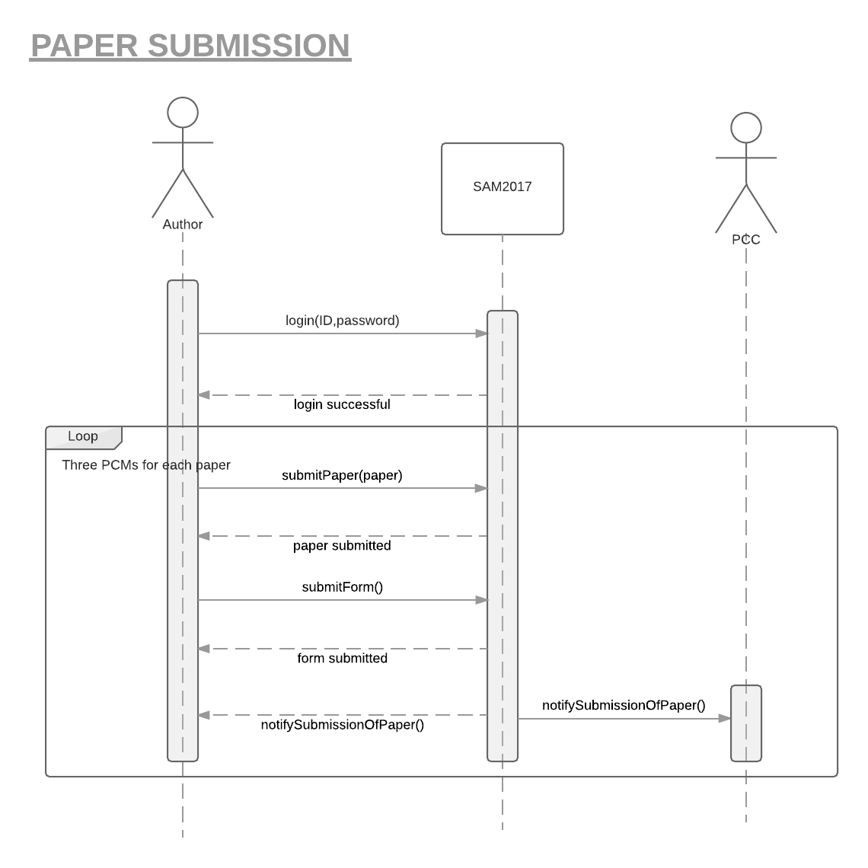

**3.2 System Sequence Diagram for Paper Assignment**

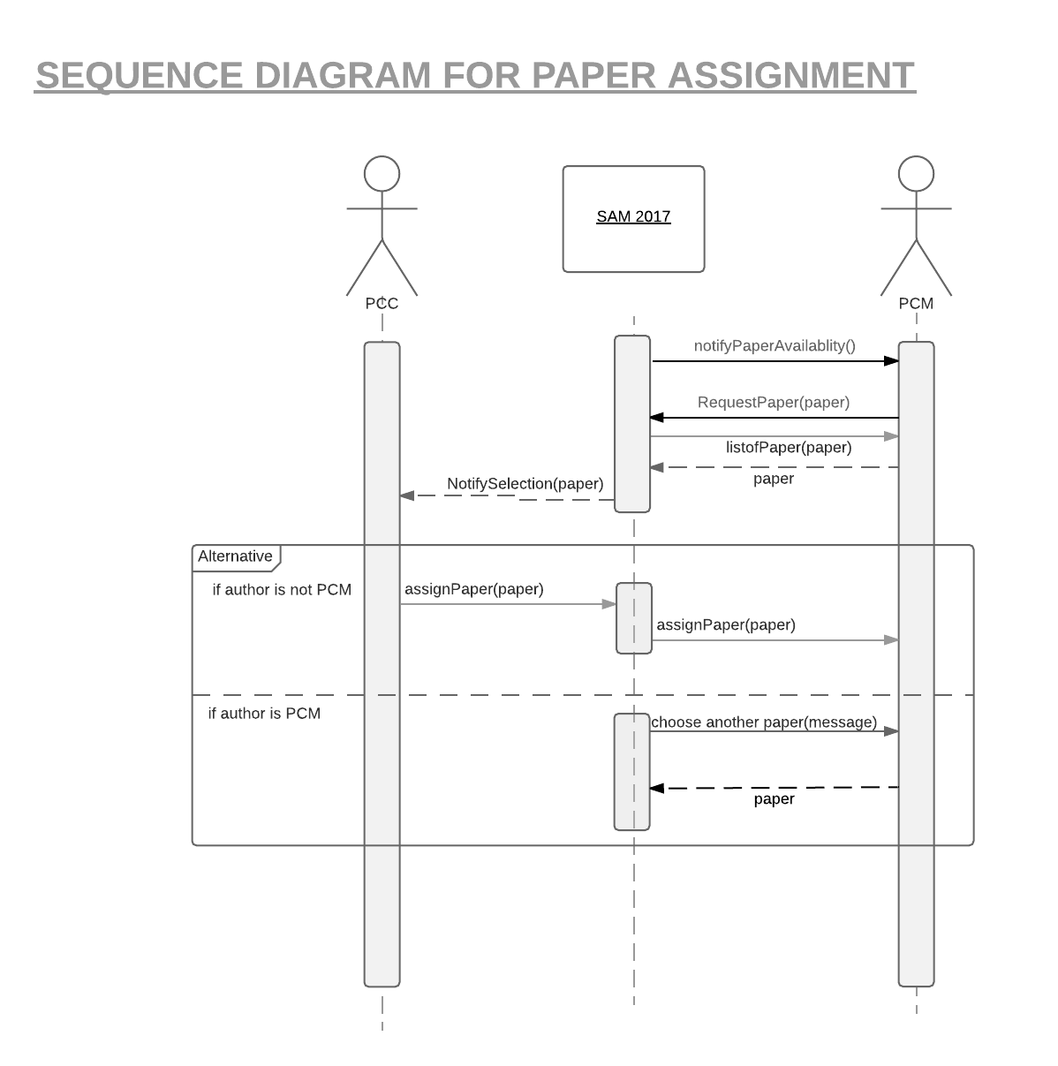

**3.3 System Sequence Diagram for Review and Rate**

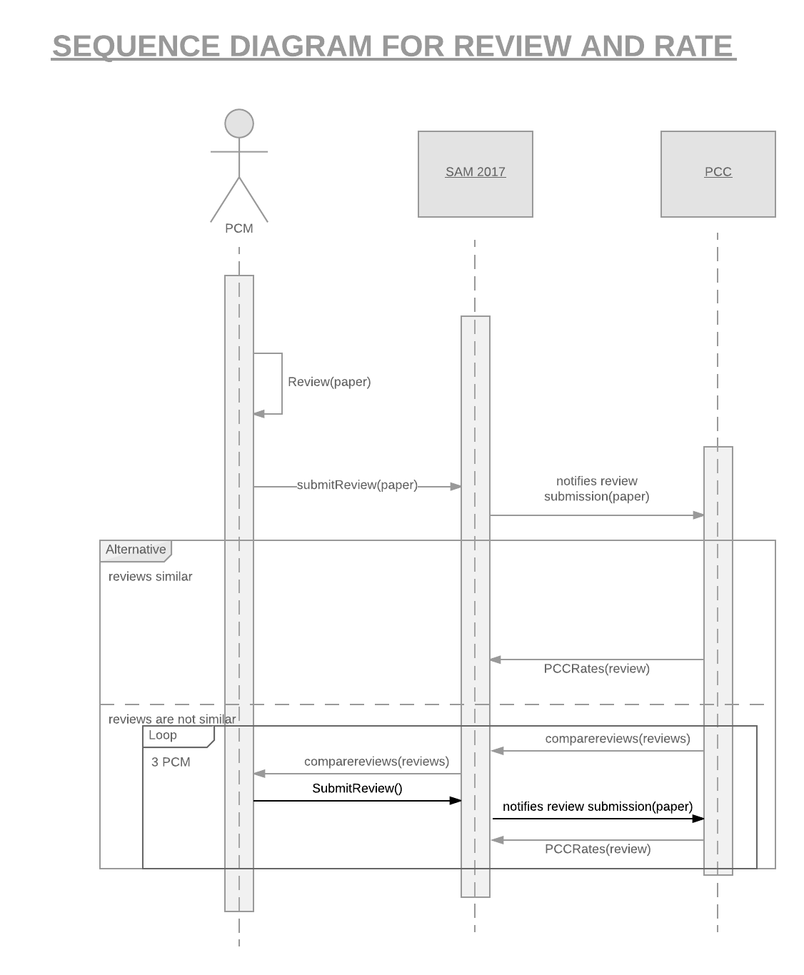

**4. Architectural Model**

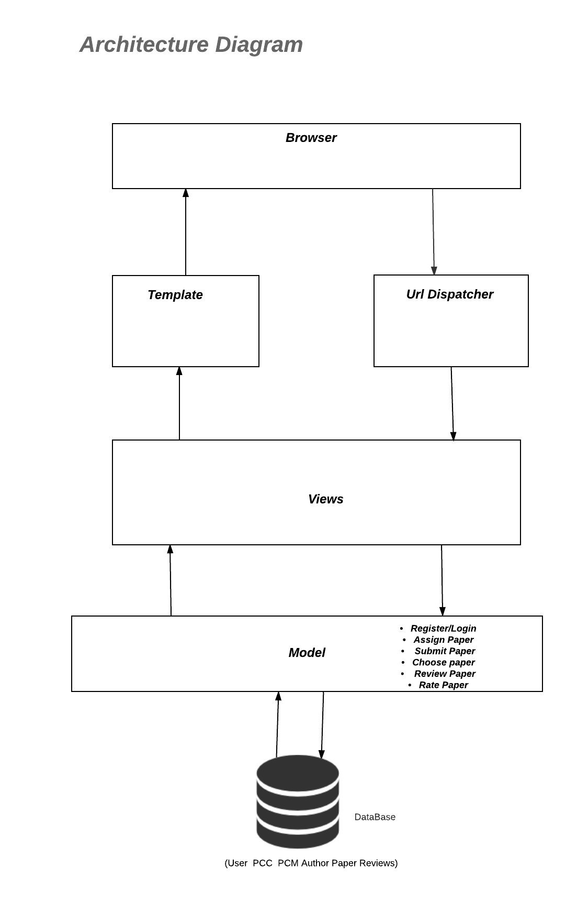

**5. Detailed Design Model**

**5.1 Class Diagram**

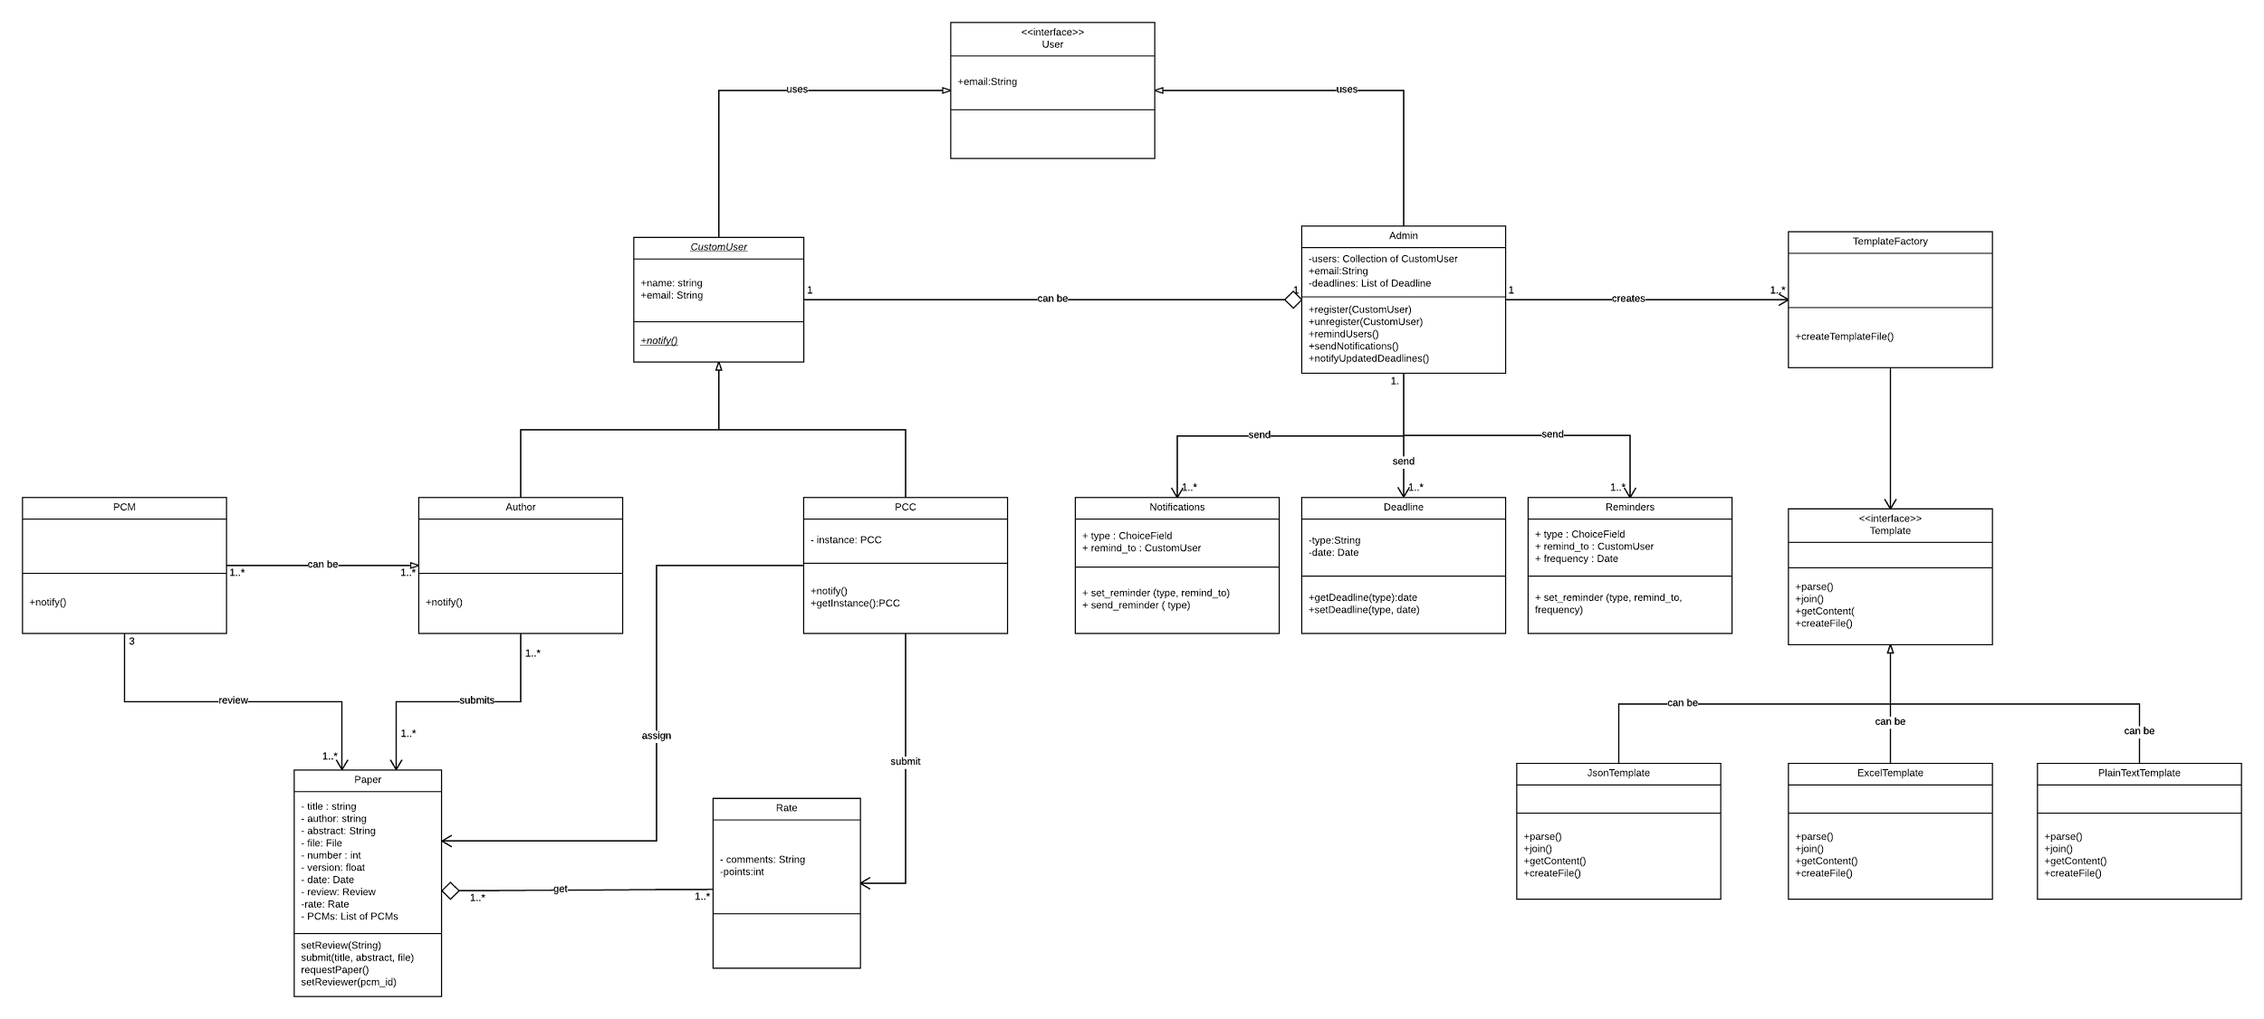

**5.2 Class Diagram using MTV**

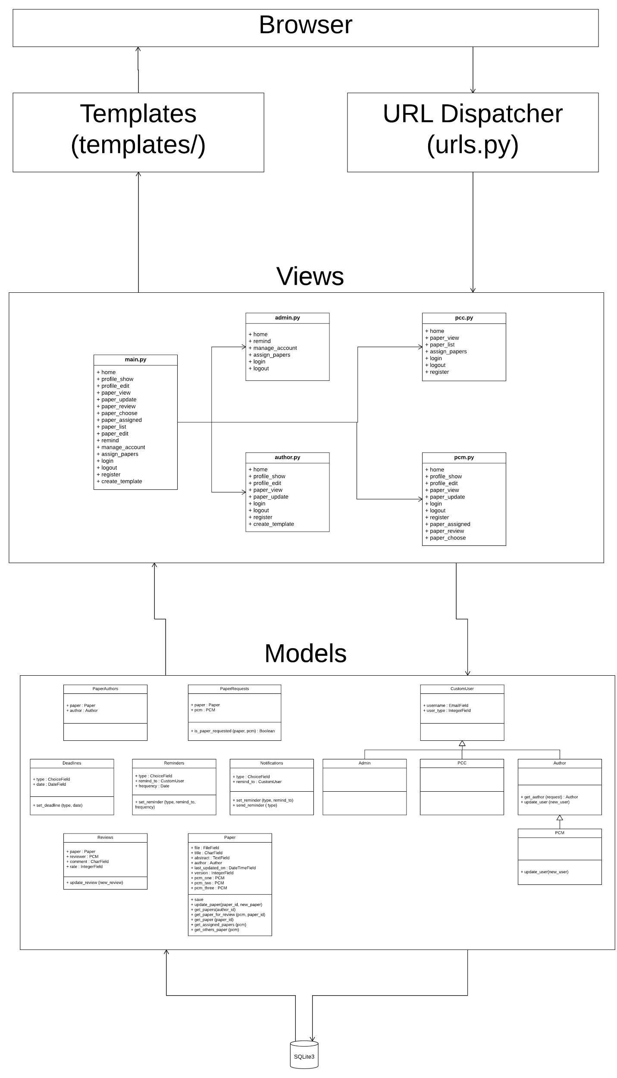

**5.3 State Diagram**

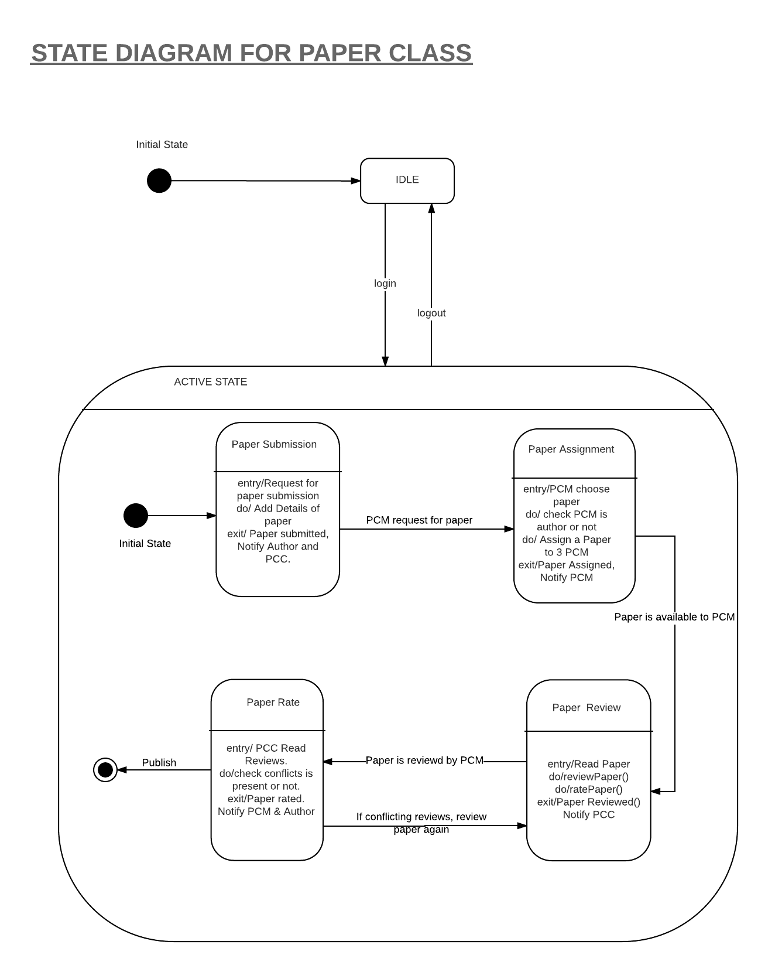

**5.4 Activity Diagram**

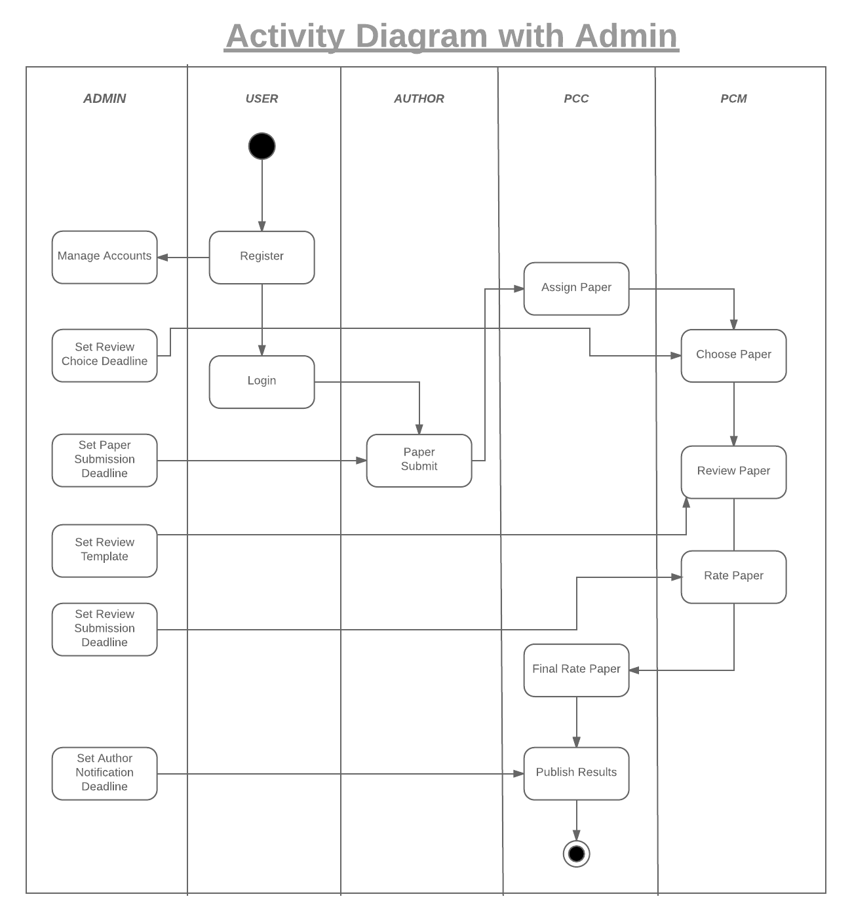

5.4.1 Activity Diagram with Admin

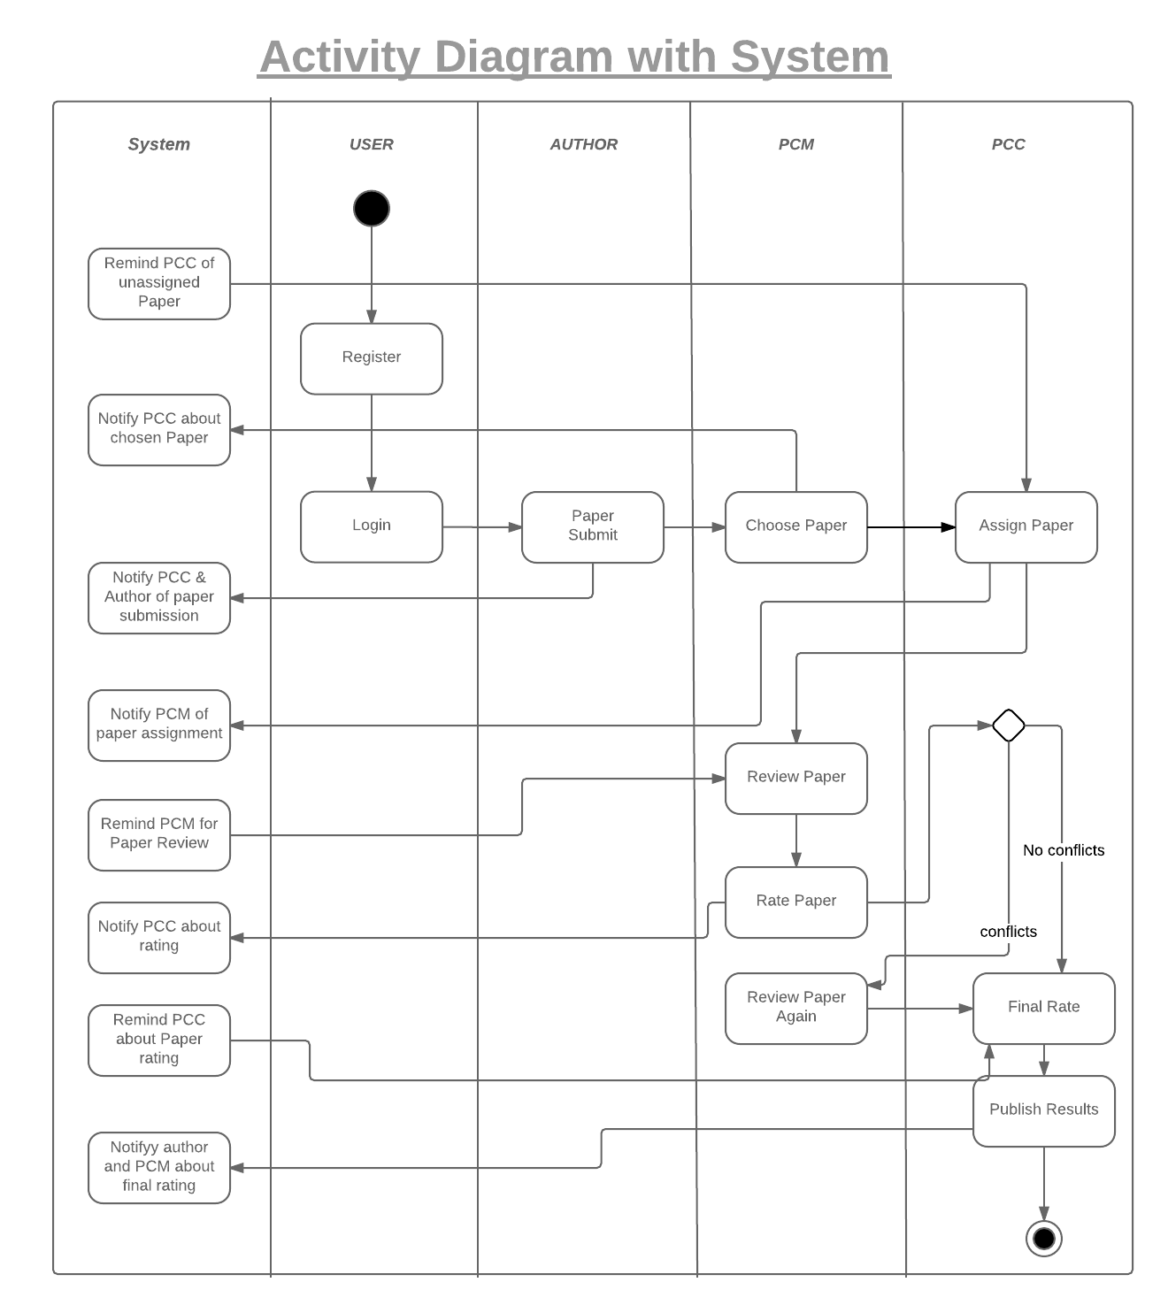

5.4.2 Activity Diagram with System

**5.5 Design Level Sequence Diagram**

